**Chapter 4**

**PRESENTATION, INTERPRETATION AND ANALYSIS OF DATA**

**4.1. Setup Dimension**

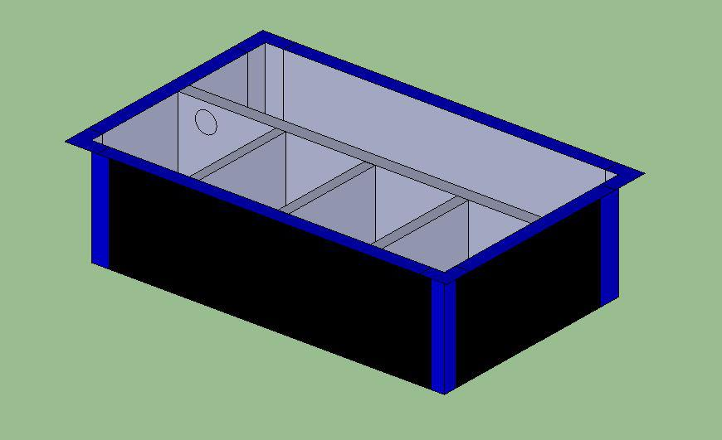

**Area 1 Main River**

**Area 2**

**Area 3**

**Figure 4.1** Setup Design and Partitions

Dimensions of River area of prototype setup (upper right):

**80cm x 25cm x 50cm**

**Vol = 100,000 cm3**

Dimensions of each of the 3 Areas of the prototype setup:

**28cm x 21.25cm x 25.25cm**

**Volume = 15023.75 cm3 or 15023.75ml**

**4.2 Experiment and Comparison of Time**

During the experiment, a uniform speed or pressure of water was used, but unfortunately there is no pressure gauge or any gadget that can measure the pressure of water that used during our experiments. However, the pressure of water used can be solved by dividing the volume over the time it took for the compartments to be full. The following are the time it took for the compartments of the setup to be full.

**Trial No.**

|  |  |  |  |  |
| --- | --- | --- | --- | --- |
|  | 1 | 2 | 3 | Average |
| Level 1 to 2 | **4mins 19 secs** | **4 mins 18 secs** | **4 mins 14 secs** | **4 mins 17 secs** |
| Level 2 to 3 | **4 mins 27 secs** | **4 mins 32 secs** | **4 mins 30 secs** | **4 mins 29 secs** |
| Level 3 to Area 1 | **4 mins 20 secs** | **4 mins 14 secs** | **4 mins 13 secs** | **4 mins 16 secs** |

**Table 4.1** Observed Time for Level Compartments to be Full

**Total Average: 13 mins 2 secs. or 782 secs.**

**Trial No.**

|  |  |  |  |  |
| --- | --- | --- | --- | --- |
|  | 1 | 2 | 3 | Average |
| Area 1 to 2 | **2 mins** | **1 min 56 secs** | **2 mins 4 secs** | **2 mins** |
| Area 2 to 3 | **2 mins** | **2 mins 2 secs** | **1 min 58 secs** | **2 mins** |

**Table 4.2** Observed Time for Area Compartments to be Full

**Total Average: 4 mins or 240 secs.**

**4.3 Mathematical Approach**

From the formula of Volume of rectangular solid which is **V = LWH**, differentiating both sides of the equation can come up with a general equation for computing the speed of change of water level height at any given amount of pressure or flow rate (dV/dT) and length and width of a particular terrain, that is:

**dV/dT** = **L** x **W** x **dH/dT**

To compute the rate of water level rising on the Main River of our prototype design given:

**L = 80 cm.**

**W = 25 cm.**

**And flow rate or dV/dT = 125 cm3/sec (flow rate used in the observed data)**

Using the equation **dV/dT** = **L** x **W** x **dH/dT,**

**dH/dT = dV/dT / (LW)**

**= 125 cm3/sec / (80cm x 25cm)**

**dH/dT = 0.0625 cm/sec**

To calculate the time it takes for the Main River to reach level 3 or be full, given **H = 50cm**:

**T = H / dH/dT = 50cm / 0.0625cm/sec.**

**T = 800 sec.**

Repeating the process for the Areas of the prototype with given dimensions:

**L = 28 cm**

**W = 21.25 cm**

Computing the speed of water level rising:

**dH/dT = dV/dT / (LW)**

**= 125 cm3/sec / (28cm x 25.25cm)**

**dH/dT = 0.1768 cm/sec.**

To calculate the time it takes for each area to reach the alert leve, given **H = 21.25cm.**

**T = H / dH/dT = 21.25 / 0.1768 cm/sec.**

**T = 120.19 sec**

**4.4 Comparing Calculated and Experimental Data**

**Calculated vs Experimental (Main River)**

%error = [ |Calculated – Experimental| / Calculated ] x 100%

= [ |800 – 782| / 800] x 100%

= **2.25%**

**(Area)**

%error = [ |Calculated – Experimental| / Calculated ] x 100%

= [ |120.19 – 120| / 120.19] x 100%

= **0.16%**

With these results, it can clearly be seen that the observed data collected is very close to the theoretical or computed values that should come up.

**4.5 SMS Sending**

**Text Messages Trial No. (time in seconds)**

|  |  |  |  |  |
| --- | --- | --- | --- | --- |
|  | 1 | 2 | 3 | Average |
| Level 1 | **7.82** | **8.84** | **8.45** | **8.37** |
| Level 2 | **8.90** | **8.77** | **8.03** | **8.57** |
| Level 3 | **8.47** | **8.69** | **8.21** | **8.46** |
| Area 1 | **8.12** | **7.87** | **8.24** | **8.08** |
| Area 2 | **7.89** | **8.45** | **8.76** | **8.37** |
| Area 3 | **8.78** | **8.65** | **8.45** | **8.63** |

**Table 4.3** SMS Sending Time

The table above shows the average time it takes for the designated mobile phone to receive alert messages from the GSM Modem from the time that the float switch is already “on.” Computing the total average time from the average time we have on the table, the total average time for the designated mobile phones to receive the alert message once the switch is already on is **8.41 seconds**. This data is based on a one-recipient for the alert messages of the system, but in actual scenario, there might be several designated mobile phones that will receive the alert messages and as expected, it will also take longer time for other designated mobile phones to receive the message. Another possible reason for delays will be the location of the system, mobile phones and nearest cell site.

For the average time for the alert message to be uploaded on the website and on social media accounts, we set the website to upload every minute, hence the longest time for it to be uploaded is **1 minute**.

**4.6 Actual Area**

Comparing the setup to the Actual area showed on our website, it can clearly be seen that the actual area is not uniform as compared to a uniform Volume or Area presented on the setup. Using the dimensions presented on google maps, it can be assumed the Area of Area 1 as approximately 30,000 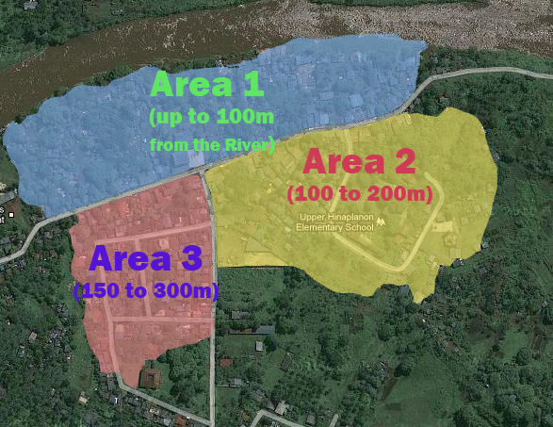sq. meters. Area 2, 25,000 sq. meters and area 3, 18,000 sq. meters.

**Figure 4.2** Location of Area setup

By the structure of the river and topography of the area, it can clearly be seen that the first area to be affected of a possible flood first will be Area 1, since the pattern of this portion of the river is an inverted U shape, once the water level continues to rise and breaks through the river wall on the right side, the next area that will be affected is Area 2 and then lastly, Area 3.

**4.7 Summary of Findings**

The volume over time used in the experiment is **0.125L/sec.**

The average time it took for water level to reach to Level 2 from 1 is **4 mins. 17 secs.**

The average time it took for water level to reach to Level 3 from 2 is **4 mins. 29 secs.**

The average time it took for water level to reach to Area 1 from Level 3 is **4 mins. 16 secs**

The calculated time for the Main River to be filled is **800 sec. or 13 mins. And 20 sec.**

The calculated time for each Area compartment to be filled is **120.19 sec or 2 mins.**

The water level rising in the water level compartment of the setup is **0.0625 cm/sec.**

The time it took for the areas of the setup to be flooded is **2 mins.**

The water level rising in the area compartment is **0.1768 cm/sec.**